GALA PROMOTER
Role

Responsible for the compilation and management of the clubs open meet programme
___________________________________________________________________________

Skills

- Well organised
- Communication Skills
- Administration Skills
- Conversant with ASA Meet Manager Software

___________________________________________________________________________

Main Duties

- Responsible for the compilation and management of the Club’s Open Meet programme (in conjunction with the Club Committee).
- Arrange appropriate TSC Open Meet Programme
- Issue Entry Forms to all club officers, officials, swimmers, notice board and Website Coordinator when available and issue invitations to other ‘local’ swimming clubs who regularly support these events.
- Manage Open Meet Entry forms (from receipt of entry with fee, through data input, programme generation and entry card/entry schedule completion) using a sub committee of helpers where deemed appropriate.
- Act as Promoter on behalf of Thanet Swim Club for all TSC Open Meets.
- To follow and promote the ASA Child Protection and Equity policies.

___________________________________________________________________________

Commitment

Currently to arrange Junior Development Gala (Feb), Thanet Primary Schools (May/Jun), Separated Medley (Jly), Thanet Open (Nov/Dec)

___________________________________________________________________________

Useful website:

ASA website: www.britishswimming.org
Sport England: www.sportengland.org.uk
NSPCC www.nspcc.org.uk
Volunteering England www.volunteering.org.uk
DO-IT www.do-it.org.uk
CSV www.csv.org.uk
Sports Coach UK www.sportscoachuk.org

Signed:

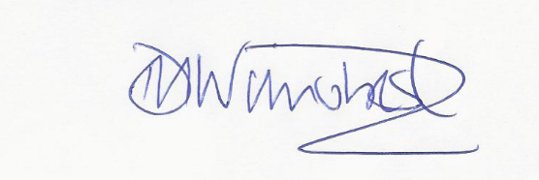

Darren Wilmshurst
Chair Thanet Swim Club

