GALA SECRETARY
Role

Responsible for the compilation and management of all gala entries
___________________________________________________________________________

Skills

- Well organised
- Communication Skills
- Administration Skills

___________________________________________________________________________

Main Duties

- Responsible for the compilation and management of the club’s 12 month gala fixtures (in conjunction with the Club Committee, Selection Sub-committee and Club Coach as appropriate).
- Issue gala invitations for inter club galas as agreed by the Club Committee and maintaining list of attendees.
- Returning acceptance slips for invitations to inter club to other clubs as agreed by the Club Committee.
- Manage and Issue the Gala Calendar to all club officers, officials, notice board, and Web Site Coordinator annually.
___________________________________________________________________________

Commitment

Intensive activity following the closing dates for galas

___________________________________________________________________________

Useful website:

ASA website: www.britishswimming.org
Sport England: www.sportengland.org.uk
NSPCC www.nspcc.org.uk
Volunteering England www.volunteering.org.uk
DO-IT www.do-it.org.uk
CSV www.csv.org.uk
Sports Coach UK www.sportscoachuk.org

Signed:

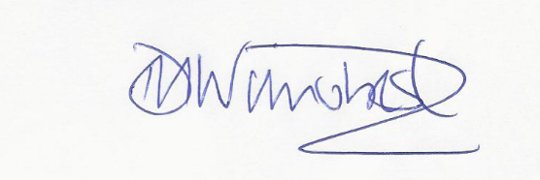

Darren Wilmshurst
Chair Thanet Swim Club

